**Software Design Description**

|  |  |  |
| --- | --- | --- |
| **System name** |  | |
| **Project team** | **Nguyen Van A** | **Leader** |
| **Tran Thi B** | **Member** |
|  |  |
|  |  |
|  |  |
|  |  |

**Revision History**

|  |  |  |  |
| --- | --- | --- | --- |
| **Version** | **Date** | **Author** | **Change Description** |
| 1.0 |  |  |  |
|  |  |  |  |

**TABLE OF CONTENTS**

1 INTRODUCTION

1.1 Purpose

1.2 Scope

1.3 Definitions, Acronyms, and Abbreviations

2 References

3 SYSTEM ARCHITECTURAL DESIGN

3.1 System Description

3.2 System Architecture

3.3 Design Constraints (optional)

3.3.1 General constraints

3.3.2 Hardware constraints

3.3.3 SW Constraints

4 Components description

4.1 Decomposition description

4.2 Detailed design

4.2.1 Class x

4.2.1.1 Attribute specification

4.2.1.2 Method specification

4.2.2 Class y

5 Database description

5.1 Database logical design

5.1.1 Table design (based on class design)

5.1.2 Normalization

5.1.3 Database diagram

5.2 Database physical design

5.2.1 Table x

5.2.2 Table y

6 External interfaces

6.1 User interfaces

6.1.1 Screen flow

6.1.2 Screen specification

6.1.2.1 Screen X

6.1.2.2 Screen Y

6.2 External system interfaces

6.2.1 Interface 1..

6.2.2 Interface 2..

7 Interaction description

8 Annexes

# INTRODUCTION

## Purpose

*Provide an overview of the entire document.*

## Scope

*Provide the document scope and intended audience*

## Definitions, Acronyms, and Abbreviations

|  |  |
| --- | --- |
| **Term/Acronym** | **Definition** |
|  |  |
|  |  |

# References

*Provide references for any pertinent document.*

# SYSTEM ARCHITECTURAL DESIGN

*Provide a general description of the system to be designed as well as the design and development methodology.*

## System Description

*Give a general description of the complete system here; preferably in form of a commented drawing. This is only for an overview and can be left out or be the same as used in the SW specification document.*

## System Architecture

*Describe the chosen system architecture. For instance, architectural design patterns can be used to describe the system: peer-to-peer, client/server, stand-alone or embebbed systems, etc.*

*Include also discussion or description of alternative designs*

## Design Constraints (optional)

### General constraints

*Describe the general constraints implied by the design process and what are the impacts on the system architecture and modules design (time, tools, resources, etc.).*

### Hardware constraints

*Describe constraints imposed by limited hardware resources.*

### SW Constraints

*Describe constraints imposed by software environment (e.g. OS, languages, etc.)*

# Components description

## Decomposition description

*Put the class diagram here.*

## Detailed design

*This section provides the internal details of each design entity. For every class, a general description needs to be provided followed by a detailed behavior specification.*

### Class x

#### Attribute specification

*List all attributes & their data types.*

#### Method specification

*Method X*

|  |  |  |
| --- | --- | --- |
|  | Name | Data type |
| **Inputs** | …  … |  |
| **Outputs** | …  … |  |
| **Algorithm specification** |  | |
| **Notes** |  | |

*Method Y*

|  |  |  |
| --- | --- | --- |
|  | Name | Data type |
| **Inputs** | …  … |  |
| **Outputs** | …  … |  |
| **Algorithm specification** |  | |
| **Notes** |  | |

### Class y

*….*

# Database description

## Database logical design

### Table design (based on class design)

*List all tables (table name, attributes, keys) which are converted from class design*

### Normalization

*Normalize tables at desired level.*

### Database diagram

*Put database diagram here.*

## Database physical design

*Indicate which database management system is used in the project, and then describe details of tables.*

### Table x

|  |  |  |  |  |
| --- | --- | --- | --- | --- |
| **No.** | **Column name** | **Datatype** | **Constraints** | **Notes** |
| 1 | Cust_ID | CHAR(10) |  |  |
| 2 | …. | … | … |  |
| 3 |  |  |  |  |
| 4 |  |  |  |  |
| 5 |  |  |  |  |

### Table y

|  |  |  |  |  |
| --- | --- | --- | --- | --- |
| **No.** | **Column name** | **Datatype** | **Constraints** | **Notes** |
| 1 | Cust_ID | CHAR(10) |  |  |
| 2 | …. | … | … |  |
| 3 |  |  |  |  |
| 4 |  |  |  |  |
| 5 |  |  |  |  |

….

# External interfaces

## User interfaces

*Describe interfaces with the various system users. Even if this information could already be described in previous related documents (i.e. SRS or analysis documents), in this section the description of this interfaces could be more specifically done as the blueprints to be followed by designers, programmers and testers.*

### Screen flow

*Illustrate flows of the screens.*

### Screen specification

#### Screen X

*Show the design of the screen which marks the item number. An example is as follows.*

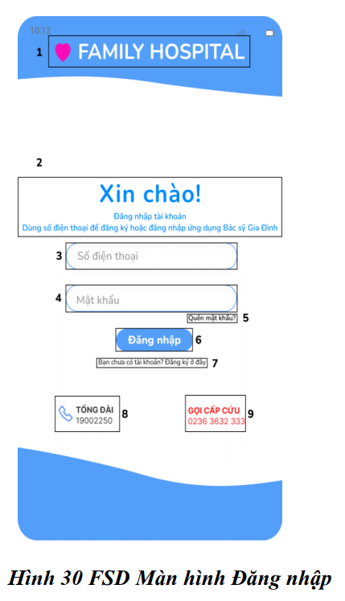

|  |  |  |  |
| --- | --- | --- | --- |
| **NO** | **LOẠI** | **MÔ TẢ** | **GHI CHÚ** |
| 1 | Logo | Hiển thị logo của Family Hospital như hình bên |  |
| 2 | Text | Hiển thị cứng "**Xin chào!**  **Đăng nhập tài khoản. Dùng số điện thoại để đăng ký hoặc đăng nhập ứng dụng Bác sỹ Gia Đình**" như hình bên |  |
| 3 | Input Text | Hiển thị ô trống nhập số điện thoại |  |
| 4 | Input Text | Hiển thị ô trống nhập mật khẩu |  |
| 5 | Button | Hiển thị cứng "**Quên mật khẩu?**"  - Sự kiện: khi nhấn vào sẽ hiển thị màn hình quên mật khẩu |  |
| 6 | Button | Hiển thị cứng "**Đăng nhập**"  - Sự kiện: khi nhấn vào sẽ hiển thị màn hình giao diện chính |  |
| 7 | Button | Hiển thị cứng "**Bạn chưa có tài khoản? Đăng ký ở đây**"  - Sự kiện: khi nhấn vào sẽ hiển thị màn hình đăng ký tài khoản |  |
| 8 | Button | Hiển thị cứng "**Tổng đài: 19002250**"  - Sự kiện : khi nhấn vào, màn hình điều hướng đến cuộc gọi |  |
| 9 | Button | Hiển thị cứng "**Gọi cấp cứu: 0236 3632 333**"  - Sự kiện : khi nhấn vào, màn hình điều hướng đến cuộc gọi |  |

#### Screen Y

…..

## External system interfaces

*Describe the interfaces with external system or software interacting with the system (if any).*

### Interface 1..

### Interface 2..

…

# Interaction description

*This part describes interactions among objects in the system. Put sequence diagrams here.*

# Annexes

*This chapter includes additional documentation (if any).*